1. **COMPONENTS LIST AND CONNECTION BLOCK DIAGRAM w/ PINS**

* Xplained mini
* Usb
* FDTI chip

1. **INITIAL/MODIFIED/DEVELOPED CODE OF TASK 1/A**

/*

* DA3A_Task1.c

*

* Created: 3/27/2019 1:46:32 PM

* Author : perezr1

*/

#define BAUD 9600

#define *F_CPU* 16000000UL

#include <avr/io.h>

#include <stdio.h>

#include <util/delay.h>

#include <avr/interrupt.h>rr

//////////////////////////// Declare functions////////////////

void USART_send(char data);

void USART_putstring(char* StringPtr);

void USART_init(void);

///////////////////////////////////////////////////////////////

char String[] = "Ricky Perez DA3A!!"; //String[] is the variable to output into terminal

char outs[20]; // contains up to 19 characters in the array.

volatile float adc_temp = 79.95; // my birthday MonDay.Year

int main(void)

{

TCCR1B = 5; // 1024 prescaler

TIMSK1 = (1<<TOIE1); // enable Overflow Interrupt in the Interrupt Mask Register

TCNT1 = 49911; // 65535-15624

USART_init();// calls function

sei();// enable interrupt

while(1)

{

// main loop

}

}

ISR (TIMER1_OVF_vect)

{

USART_putstring(String); // prints string

USART_putstring("\n"); // create a new line.

USART_send('7'); // In decimal its 55. also my birth month :D

USART_putstring("\n"); // create a new line.

*snprintf*(outs, sizeof(outs), "%f\r\n", adc_temp); // the floating point characters are stored in outs

USART_putstring(outs); // transmits outs to UART

TCNT1 = 49911; // reset

}

void USART_init( void )

{

UBRR0H = 0; //USART Baud Rate Register high

UBRR0L = *F_CPU*/16/BAUD - 1;// USART Baud Rate Register low: BAUD prescaler

UCSR0C = _BV(UCSZ01) | _BV(UCSZ00); /* 8-bit data */

UCSR0B = _BV(RXEN0) | _BV(TXEN0); /* Enable RX and TX */

}

void USART_send(char data) // sends data/ integer

{

while (!(UCSR0A & (1 << UDRE0)));//USART Control and Status Register & ?USART Data Register Empty

UDR0 = data;

}

void USART_putstring(char *StringPtr) // prints strings in terminal

{

while ((*StringPtr != '\0')){

while (!(UCSR0A & (1 << UDRE0)));

UDR0 = *StringPtr;

StringPtr++;

}

}

1. **SCHEMATICS**

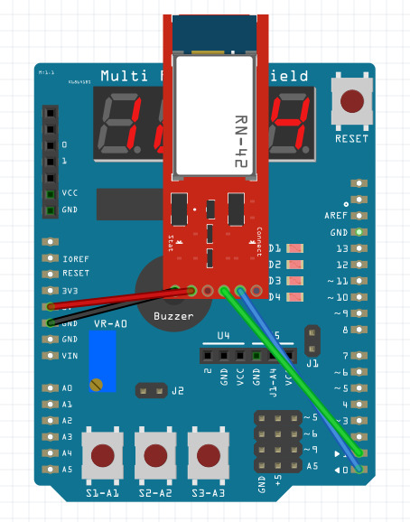

1. **SCREENSHOTS OF EACH TASK OUTPUT (ATMEL STUDIO OUTPUT)**

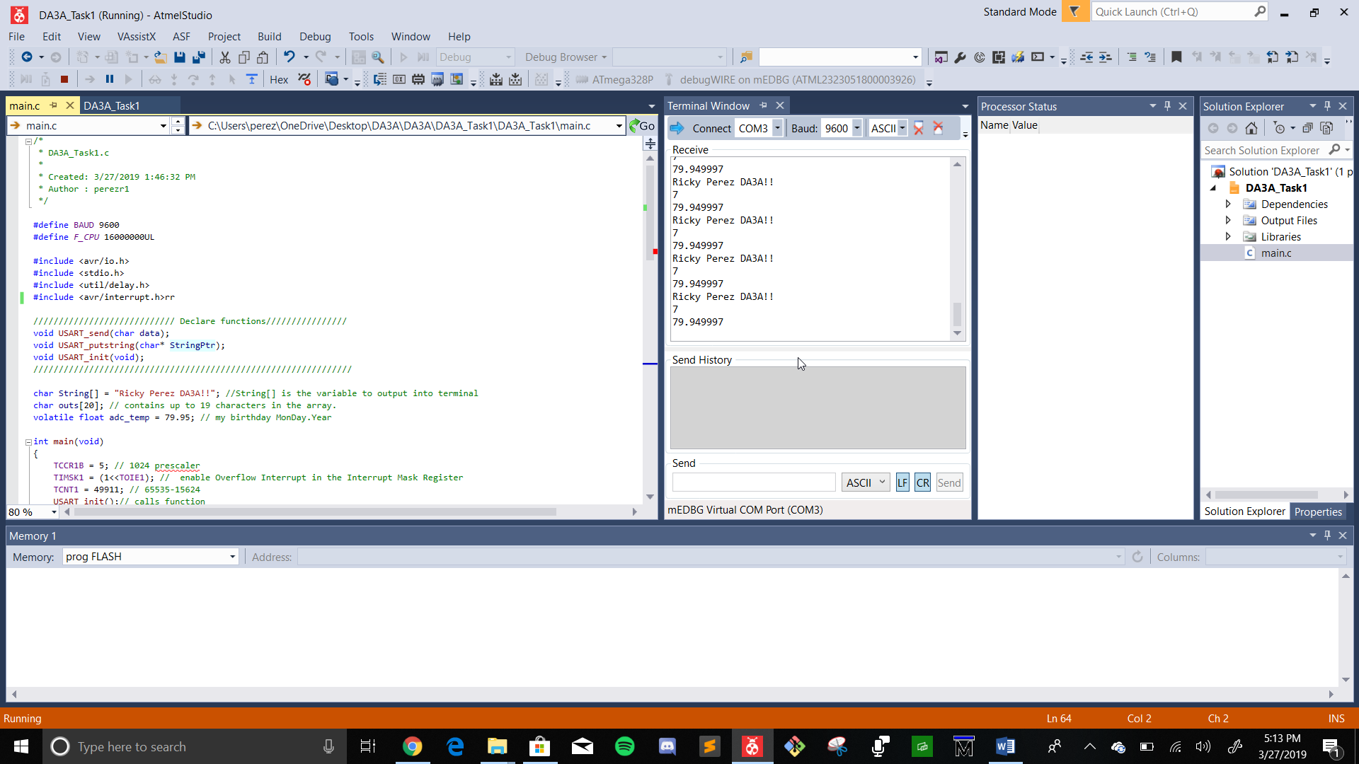

1. **SCREENSHOT OF EACH DEMO (BOARD SETUP)**

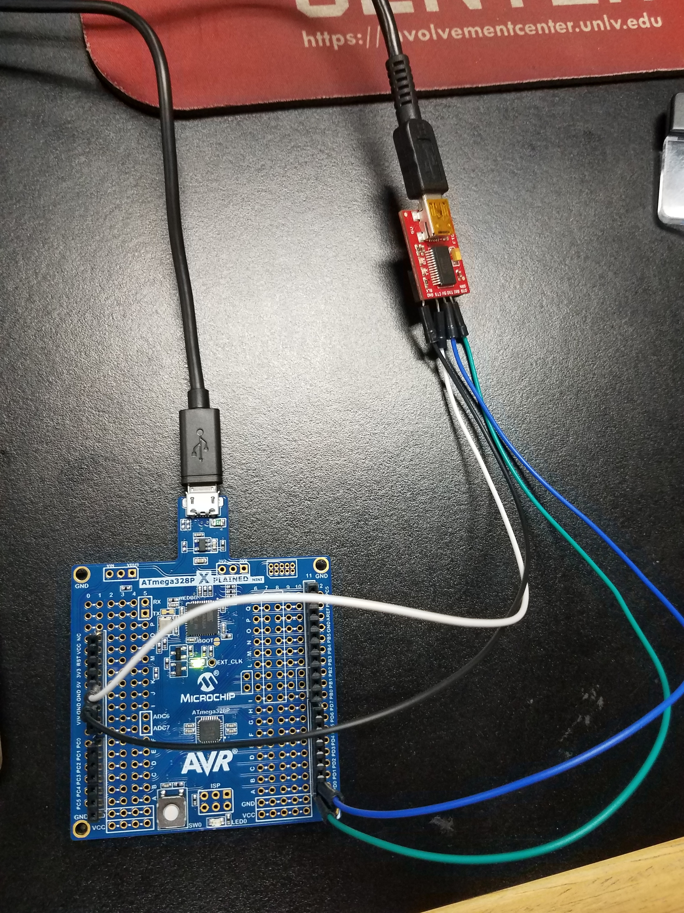

1. **VIDEO LINKS OF EACH DEMO**

<https://youtu.be/_BMCoUl0NbQ>

1. **GITHUB LINK OF THIS DA**

<https://github.com/RickyPerez79/submission_da.git>

**Student Academic Misconduct Policy**

<http://studentconduct.unlv.edu/misconduct/policy.html>

“This assignment submission is my own, original work”.

RICKY PEREZ